实验（2）—— 基本语法

学生姓名：黄伟杰 专业班级：计算机211
课程名称：面向对象程序设计 实验类型：综合

一 实验目的
练习C++基本语法。

二 实验环境
PC机 + Windows 10操作系统 + CodeBlocks 集成开发环境

三 实验内容
1 打印输出C++常用的数据类型的字节数
#include <iostream>
using namespace std;
void solve() {
cout << "the size of 'bool' is:" << sizeof(bool) << endl;
cout << "the size of 'char' is:" << sizeof(char) << endl;
cout << "the size of 'short' is:" << sizeof(short) << endl;
cout << "the size of 'int' is:" << sizeof(int) << endl;
cout << "the size of 'long' is:" << sizeof(long) << endl;
cout << "the size of 'long long' is:" << sizeof(long long) << endl;
cout << "the size of 'float' is:" << sizeof(float) << endl;
cout << "the size of 'double' is:" << sizeof(double) << endl;
}
int main() {
solve();
return 0;
}
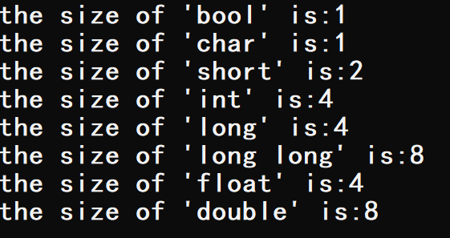
2 打印输出ASCII码为32-127的字符
#include <iostream>
using namespace std;
void solve() {
for (int i = 32; i <= 127; i ++) printf("%c ", i);
}
int main() {
solve();
return 0;
}
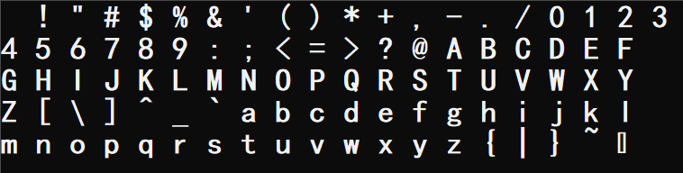
3 提示用户“你考了几分？”，接收输入后判断其等级，并显示等级（优：90--100；良：80--90；中：60--80；差0--60）
#include <iostream>
using namespace std;
int level(int score) {
switch (score / 10) {
case 0: case 1: case 2: case 3: case 4: case 5: return 0;
case 6: case 7: return 1;
case 8: return 2;
case 9: case 10: return 3;
}
return 0;
}
int main() {
int lv;
cout << "你考了几分？" << endl;
lv = level(55);
switch (lv) {
case 0: printf("55分，鉴定为：差！\n"); break;
case 1: printf("68分，鉴定为：中！\n"); break;
case 2: printf("85分，鉴定为：良！\n"); break;
case 3: printf("95分，鉴定为：优！\n"); break;
}
lv = level(68);
switch (lv) {
case 0: printf("55分，鉴定为：差！\n"); break;
case 1: printf("68分，鉴定为：中！\n"); break;
case 2: printf("85分，鉴定为：良！\n"); break;
case 3: printf("95分，鉴定为：优！\n"); break;
}
lv = level(85);
switch (lv) {
case 0: printf("55分，鉴定为：差！\n"); break;
case 1: printf("68分，鉴定为：中！\n"); break;
case 2: printf("85分，鉴定为：良！\n"); break;
case 3: printf("95分，鉴定为：优！\n"); break;
}
lv = level(95);
switch (lv) {
case 0: printf("55分，鉴定为：差！\n"); break;
case 1: printf("68分，鉴定为：中！\n"); break;
case 2: printf("85分，鉴定为：良！\n"); break;
case 3: printf("95分，鉴定为：优！\n"); break;
}
return 0;
}
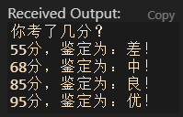
4 找出1--1000间的所有的回文数，并显示。分别使用while do-while for 实现
#include <iostream>
using namespace std;
void whiletype() {
cout << "while version" << endl;
int i = 10;
while (i <= 999) {
i ++;
if (i < 100 && !(i % 11)) cout << i << " ";
if (i > 100 && i % 10 == i / 100) cout << i << " ";
}
puts("");
}
void dowhiletype() {
cout << "do-while version" << endl;
int i = 10;
do {
i ++;
if (i < 100 && !(i % 11)) cout << i << " ";
if (i > 100 && i % 10 == i / 100) cout << i << " ";
}while (i <= 999);
puts("");
}
void fortype() {
cout << "for version" << endl;
for (int i = 11; i <= 999; i ++) {
if (i < 100 && !(i % 11)) cout << i << " ";
if (i > 100 && i % 10 == i / 100) cout << i << " ";
}
puts("");
}
int main() {
whiletype();
dowhiletype();
fortype();
return 0;
}
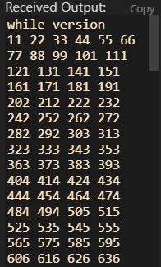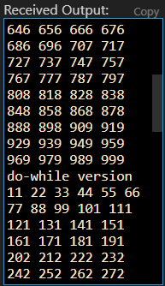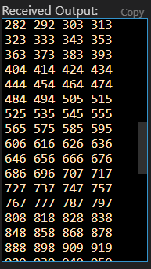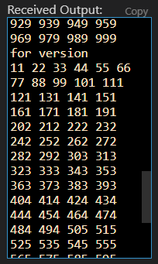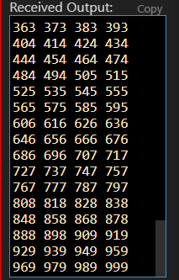
5 输入两个正整数a，b，将a，b化为二进制数，然后将这两个二进制数作二进制加法运算，再将结果化为十进制数输出
#include <iostream>
#include <cstring>
#include <cmath>
using namespace std;
void dectobin(char *bin, int n) {
int x, i = 0;
while (n) {
x = n % 2;
n = n >> 1;
*(bin + i) = x + '0';
i ++;
}
*(bin + i) = '\0';
}
void addbin(char *s1, char *s2, int *ans_bin, int &cnt) {
int k = 0; cnt = 0;
for (int i = 0; *(s1 + i); i ++) {
k += *(s1 + i) - '0';
if (*(s2 + i)) k += s2[i] - '0';
ans_bin[cnt ++] = k % 2;
k /= 2;
}
if (k) ans_bin[cnt ++] = 1;
}
void bintodec(int *ans_bin, int cnt, int &ans_dec) {
ans_dec = 0;
for (int i = 0; i < cnt; i ++) ans_dec += ans_bin[i] * pow(2, i);
}
int main() {
int a, b, ans_bin[25], cnt, ans_dec;
char bin_a[25], bin_b[25];
a = 15, b = 10;
printf("a = %d, b = %d\n", a, b);
dectobin(bin_a, a); dectobin(bin_b, b);
printf("a(B) = "); for (int i = strlen(bin_a) - 1; i >= 0; i --) cout << bin_a[i]; printf(", ");
printf("b(B) = "); for (int i = strlen(bin_b) - 1; i >= 0; i --) cout << bin_b[i]; printf("\n");
addbin(bin_a, bin_b, ans_bin, cnt);
printf("a(B) + b(B) = ");
for (int i = cnt - 1; i >= 0; i --) cout << ans_bin[i];
bintodec(ans_bin, cnt, ans_dec);
printf("(B), %d(D)\n", ans_dec);
a = 18, b = 8;
printf("a = %d, b = %d\n", a, b);
dectobin(bin_a, a); dectobin(bin_b, b);
printf("a(B) = "); for (int i = strlen(bin_a) - 1; i >= 0; i --) cout << bin_a[i]; printf(", ");
printf("b(B) = "); for (int i = strlen(bin_b) - 1; i >= 0; i --) cout << bin_b[i]; printf("\n");
addbin(bin_a, bin_b, ans_bin, cnt);
printf("a(B) + b(B) = ");
for (int i = cnt - 1; i >= 0; i --) cout << ans_bin[i];
bintodec(ans_bin, cnt, ans_dec);
printf("(B), %d(D)\n", ans_dec);
a = 118, b = 25;
printf("a = %d, b = %d\n", a, b);
dectobin(bin_a, a); dectobin(bin_b, b);
printf("a(B) = "); for (int i = strlen(bin_a) - 1; i >= 0; i --) cout << bin_a[i]; printf(", ");
printf("b(B) = "); for (int i = strlen(bin_b) - 1; i >= 0; i --) cout << bin_b[i]; printf("\n");
addbin(bin_a, bin_b, ans_bin, cnt);
printf("a(B) + b(B) = ");
for (int i = cnt - 1; i >= 0; i --) cout << ans_bin[i];
bintodec(ans_bin, cnt, ans_dec);
printf("(B), %d(D)\n", ans_dec);
return 0;
}
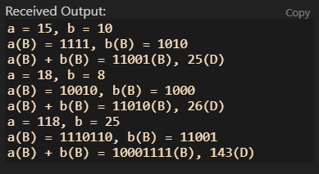
6 编写一个函数判断一个数是否为水仙花数
#include <iostream>
using namespace std;
int solve(int x) {
int t = x, ans = 0, k;
while (t) {
k = t % 10;
t /= 10;
ans += k * k * k;
}
if (ans == x) return 1;
else return 0;
}
int main() {
int n;
n = 153;
if (solve(n)) printf("%d YES\n", n);
else printf("%d NO\n", n);
n = 256;
if (solve(n)) printf("%d YES\n", n);
else printf("%d NO\n", n);
n = 407;
if (solve(n)) printf("%d YES\n", n);
else printf("%d NO\n", n);
return 0;
}
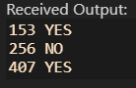
7 计算字符串长度 int mystrlen(char *p)
#include <iostream>
using namespace std;
const int M = 110;
int my_strlen(char *p) {
int len = 0;
for (; *(p + len); len ++);
return len;
}
int main() {
char s1[M] = "hello world:)";
printf("the lenth of '%s' is %d\n", s1 ,my_strlen(s1));
char s2[M] = "\\i love c++/";
printf("the lenth of '%s' is %d\n", s2 ,my_strlen(s2));
char s3[M] = "cpp yes:) python no:(";
printf("the lenth of '%s' is %d\n", s3 ,my_strlen(s3));
return 0;
}
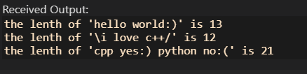
8 统计在一个输入字符串中各个不同字符出现的次数，按最多到最少的顺序依次打印
#include <iostream>
#include <algorithm>
using namespace std;
const int M = 110;
struct node {
int ascii_no;
int f;
}ascii[128];
bool cmp(struct node a, struct node b) {
return a.f > b.f;
}
void solve(char *str) {
for (int i = 0; *(str + i); i ++) ascii[*(str + i)].f ++;
sort(ascii, ascii + 128, cmp);
}
int main() {
for (int i = 0; i <= 127; i ++) ascii[i].ascii_no = i;
for (int i = 0; i <= 127; i ++) ascii[i].f = 0;
char s1[M] = "hello world:)";
solve(s1);
for (int i = 0; i <= 127 ; i++)
if (ascii[i].f) printf("%c's frequency is %d\n", ascii[i].ascii_no, ascii[i].f);
puts("");
for (int i = 0; i <= 127; i ++) ascii[i].f = 0;
char s2[M] = "i love c++!";
solve(s2);
for (int i = 0; i <= 127 ; i++)
if (ascii[i].f) printf("%c's frequency is %d\n", ascii[i].ascii_no, ascii[i].f);
puts("");
for (int i = 0; i <= 127; i ++) ascii[i].f = 0;
char s3[M] = "cpp yes:) python no:(";
solve(s3);
for (int i = 0; i <= 127 ; i++)
if (ascii[i].f) printf("%c's frequency is %d\n", ascii[i].ascii_no, ascii[i].f);
return 0;
}
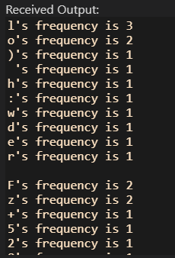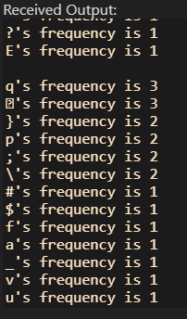
9 编写函数求一个整型数组的均值
#include <iostream>
using namespace std;
const int M = 10;
double aver(int arr[], int n) {
int sum = 0;
for (int i = 0; i < n; i ++) sum += arr[i];
return (double)sum / (double)n;
}
int main() {
int n = 10;
int arr1[M] = {0, 1, 2, 3, 4, 5, 6, 7, 8, 9};
printf("the average of arr1 is %.2lf\n", aver(arr1, n));
int arr2[M] = {0, 15, 52, 23, 114, 5545, 116, 17, 68, 989};
printf("the average of arr2 is %.2lf\n", aver(arr2, n));
int arr3[M] = {50, 211, 52, 37, 45, 415, 1116, 657, 748, 149};
printf("the average of arr3 is %.2lf\n", aver(arr3, n));
return 0;
}
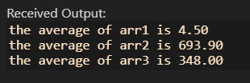
10 编写投骰子游戏。有甲乙两个玩家，轮流投骰子。先投出6点者（若某玩家第一轮投不出6点，则需一直投，直到投出6点），可以开始累计点数，累计先达到30点的玩家为赢家。要求在屏幕中清楚地复现整个游戏的过程，仅让用户在游戏开始前输入一个种子数即可。
#include <iostream>
#include <cstdlib>
using namespace std;
int solve() {
int flag1 = 0, flag2 = 0;
int sum1 = 0, sum2 = 0, i = 0;
while (sum1 < 30 && sum2 < 30) {
i ++;
int die1 = rand() % 6 + 1;
int die2 = rand() % 6 + 1;
if (flag1) sum1 += die1;
if (flag2) sum2 += die2;
if (die1 == 6) flag1 = 1;
if (die2 == 6) flag2 = 1;
printf("Round %d: 甲 %d vs %d 乙\n累计点数: 甲 %d vs %d 乙\n", i, die1, die2, sum1, sum2);
}
if (sum1 >= 30 && sum2 >= 30) return 0;
else if (sum1 >= 30) return 1;
else return 2;
}
int main() {
int seed;
seed = 5;
srand(seed);
switch (solve()) {
case 0: cout << "平局！" << endl; break;
case 1: cout << "The winner is 甲!" << endl; break;
case 2: cout << "The winner is 乙!" << endl; break;
}
puts("");
seed = 10;
srand(seed);
switch (solve()) {
case 0: cout << "平局！" << endl; break;
case 1: cout << "The winner is 甲!" << endl; break;
case 2: cout << "The winner is 乙!" << endl; break;
}
puts("");
seed = 15;
srand(seed);
switch (solve()) {
case 0: cout << "平局！" << endl; break;
case 1: cout << "The winner is 甲!" << endl; break;
case 2: cout << "The winner is 乙!" << endl; break;
}
return 0;
}
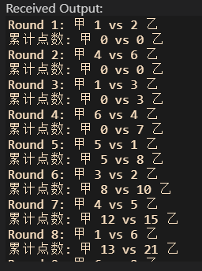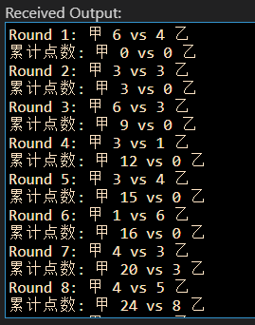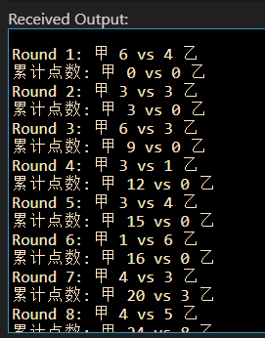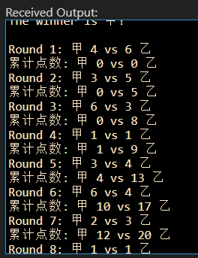
四 实验小结
巩固了C++的基本语法。

